**Day 3 - API Integration And Data Migration Report**

**Document Title: Day 3 - API Integration Report – E-commerce-template-4**  
  
Code snippets for:  
- API integration functions.  
- Data migration scripts.  
 **API Integration and Data Migration Details:**

In this report, I detail the process I followed to integrate the provided product API with Sanity CMS, as part of a hackathon project.  
  
 **API Integration Steps:**  
- I used the provided product API and created a Sanity backend project in the hackathon repository.  
- Created a 'product.ts' file for the product schema inside the Sanity project.  
- The schema was structured with necessary fields for the product, including name, image, price, description, etc.  
- I added a .env file to securely store the project ID and API token for the Sanity project.  
  
 **Schema Adjustments:**  
- Inside the product.ts file, I defined the schema with the appropriate types and validation rules for each field.- This ensures that products are well-structured and validated when added to the Sanity CMS.  
 **Data Migration Methods:**  
- I created a 'scripts' folder and added a 'import-data.mjs' file that handled the migration process.  
- Installed all required dependencies necessary for data import and migration.  
- After configuring the API with Sanity and setting up the required environment variables, I migrated the data into the Sanity CMS successfully.

**API response:**

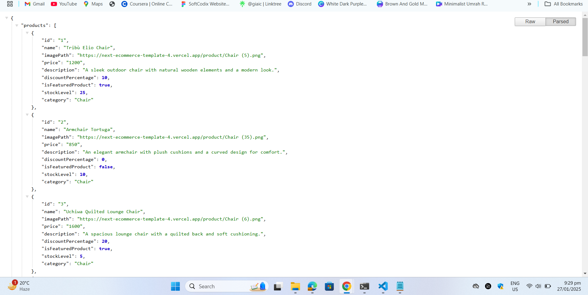

**Frontend Data Display:**

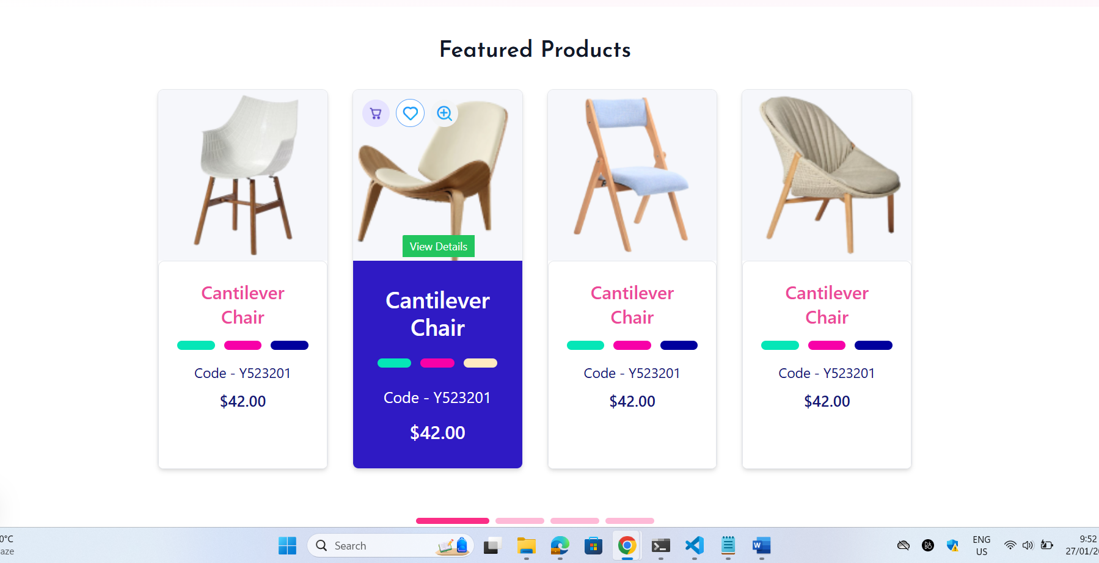

**Sanity product data Display:**

